



A good thing. A bad thing.

You want to tell us.
Our form.
You want to tell us some thing.
It may be good. Like we did a good job.
It may be bad. Like there is a problem.
Tick the box that is right for you.
And
Write on the lines.
You want to know about this form. Like
- what it is for
- who can use it
- you do it. You give it to us. What we do with it.
Read A good thing. A bad thing. You want to tell us.
You may need help with this form. You can ask
- a person you know. They may be a friend. They may be family
- a person who helps you. Like a support worker
- your local church. They will find help for you.


Your name
You want to write your name on the form. Go to question 1. It is on page 3.
Or
You do not want to write your name. That is OK. Go to question 5. It is on page 4.


About you
- Your name.
Click or tap here to enter text.
- Where you live. You do not have to answer this.
Click or tap here to enter text.
- Your phone number.
Click or tap here to enter text.
- Your email.
Click or tap here to enter text.


- This form is for you. Does a person help you?
- No. You do the form by your self. Go to question 8. It is on page 4.
- Yes. A person helps you. Go to the next question.

- The person who helps you. Their name.
Click or tap here to enter text.
- How you know them. They may be
- your mum
- a friend
- your support worker.
Click or tap here to enter text.

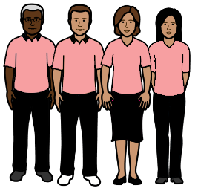
- What do you want to tell us?
About a person. Write their name.
Click or tap here to enter text.
Or
About a group. Like church council. Write the group name
Click or tap here to enter text.
Or
A thing that happened. It may be
- at church. Like at Sunday service.
- at an event. Like Friday morning tea.
Write where it happened.
Click or tap here to enter text.
- Was it a
- good thing. Like we did a good job. It may be people at church are nice.
- small bad thing. Like we did not do a good job.
It may be the music is too loud.
- bad thing. Like some thing went wrong. It may be the church has no ramp.

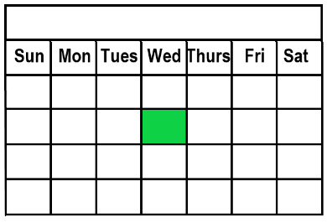
- When was it?
____________\___________\____________
Or
You may not know the date. That is OK. Tell us what you do know. Like it was
- about a week ago
- last year
- in summer.
Click or tap here to enter text.

- Where was it?
Where did this happen? A church. Like the church you go to. Write the church name.
Click or tap here to enter text.
Or
A different place. Like church camp. Write it here.
Click or tap here to enter text.


- What happened?
You can write as much as you want. You can add pages.
Click or tap here to enter text.


- How can we talk to you?
Meet face to face.
Talk on the phone. We will call you.
A letter.
Email.
A different way.
Write it here.
Click or tap here to enter text.
- The date today
____________\___________\____________
You finish this form. Give it back to your local church.
Give to your Safe Church Person.
You may
- need more space
- want to take notes.
You can write here.
Click or tap here to enter text.

This form is based on Compliments, Concerns and Complaints (3Cs) Guidelines, The Uniting Church in Australia Synod of Victoria and Tasmania. 2026.
We can use these images. We did not use AI in any part of this project.
Access Easy English wrote the Easy English. May 2026.

